Part Number: PT938-42130-XX

Kit Contents
Item # | Quantity Reqd. | Description
1 | 1 | Molding, LH Front Door
2 | 1 | Molding, LH Rear Door
3 | 1 | Molding, RH Front Door
4 | 1 | Molding, RH Rear Door
Hardware Bag Contents
Item # | Quantity Reqd. | Description
1
2
Additional Items Required For Installation
Item # | Quantity Reqd. | Description
1
2
Conflicts
None
Recommended Tools
Personal & Vehicle Protection | Notes
Safety Glasses
Vehicle Protection | Seat & Floor Covers
Special Tools | Notes
Roller | Hard Rubber Hand Roller, 1” to 3” wide.
Placement Fixtures | RAV413-061-01 (LHS)  RAV413-061-02 (RHS)
Installation Tools | Notes
Flexible Scale or Tape Measure
Masking Tape | 1-2” wide
Clean Lint-free Cloths
Non intrusive Infrared Temp Probe/Gun
Non-marring straight edge
Heat Gun
Special Chemicals | Notes
Cleaner | VDC approved cleaner and cleaning method

General Applicability
Body Side Molding can be installed on all RAV4 models
Recommended Sequence of Application
Item # | Accessory
1 | Body Side Molding – Can be installed in any sequence with other accessories
2 | Door Edge Guard
*Mandatory

Vehicle Service Parts (may be required for reassembly)
Item # | Quantity Reqd. | Description
Legend
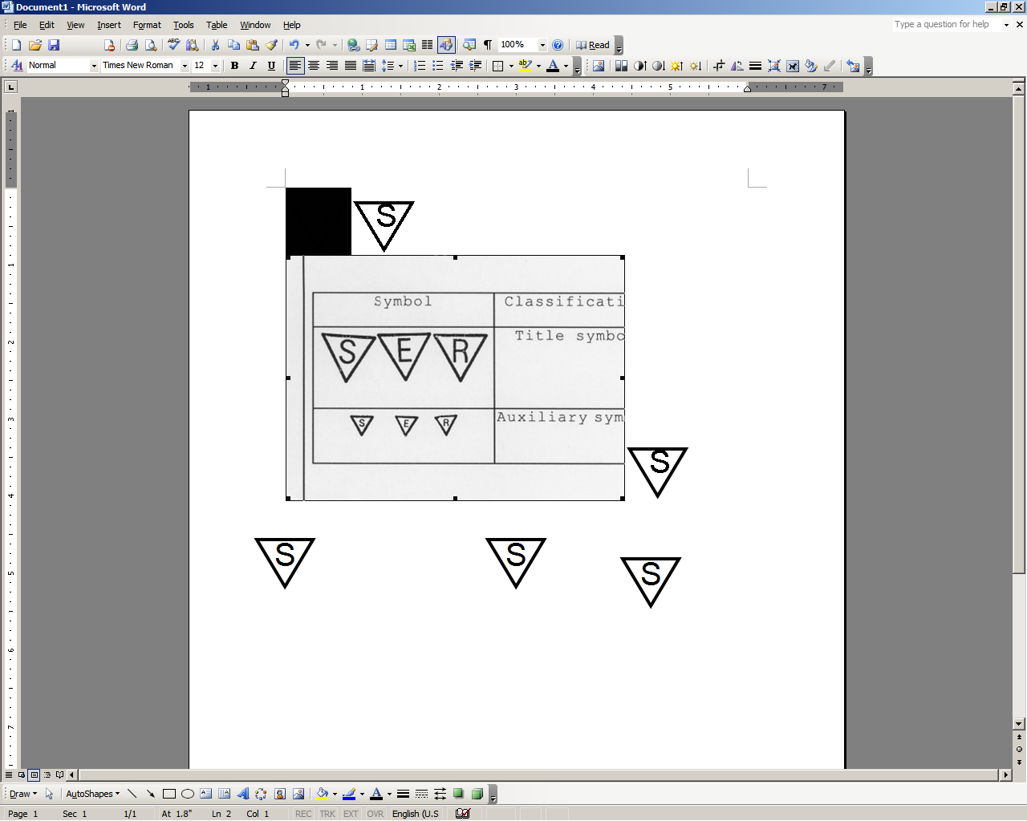




STOP: Damage to the vehicle may occur. Do not proceed until process has been complied with.
OPERATOR SAFETY: Use caution to avoid risk of injury.
CAUTION: A process that must be carefully observed in order to reduce the risk of damage to the accessory/vehicle and to ensure a quality installation.
TOOLS & EQUIPMENT: Used in Figures calls out the specific tools and equipment recommended for this process.
REVISION MARK: This mark highlights a change in installation with respect to previous issue.

SAFETY TORQUE: This mark indicates that torque is related to safety.

Care must be taken when installing this accessory to ensure damage does not occur to the vehicle. The installation of this accessory should follow approved guidelines to ensure a quality installation.

These guidelines can be found in the "Accessory Installation Practices" document.

This document covers such items as:
- Vehicle Protection (use of covers and blankets, cleaning chemicals, etc.).
- Safety (eye protection, rechecking torque procedure, etc.).
- Vehicle Disassembly/Reassembly (panel removal, part storage, etc.).
- Electrical Component Disassembly/Reassembly (battery disconnection, connector removal, etc.).

Please see your Toyota dealer for a copy of this document.

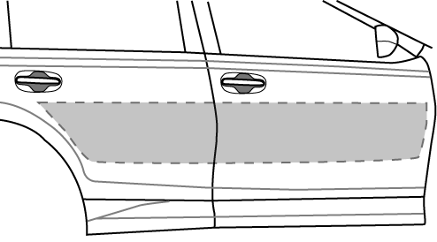
Vehicle Preparation
Fig. 1-1

  - The work area, body side moldings, and vehicle door surface temperature must be between 60˚F and 110 ˚F.
  - Clean the door area as shown using a non-scratch cloth and a VDC approved cleaner and cleaning method. (Fig. 1-1)
  - Wipe the cleaned surfaces with a clean, dry, lint-free cloth

NOTE: Once cleaned do not contaminate this surface by touching it with your bare hands

Applying Placement Fixture
  - Apply Protective Tape to all 4 door handles. (Fig. 2-1)

  - Starting with either the LH or RH placement fixture, place the top fixture locators into the front and rear door handles. (Fig. 2-2)
Fig. 2-1
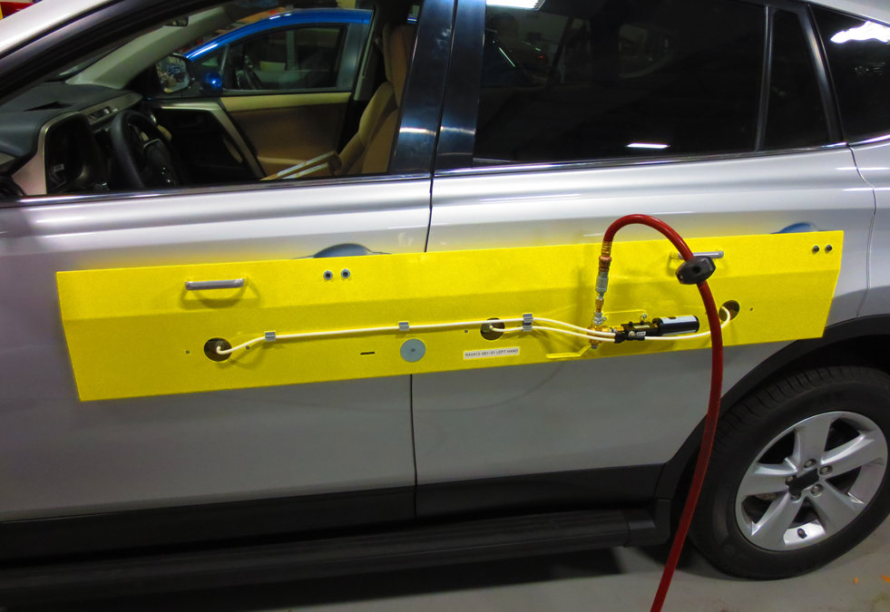
Fixture Locators
Vacuum Actuator

Fig. 2-2
Spacer Blocks
Vacuum Cups
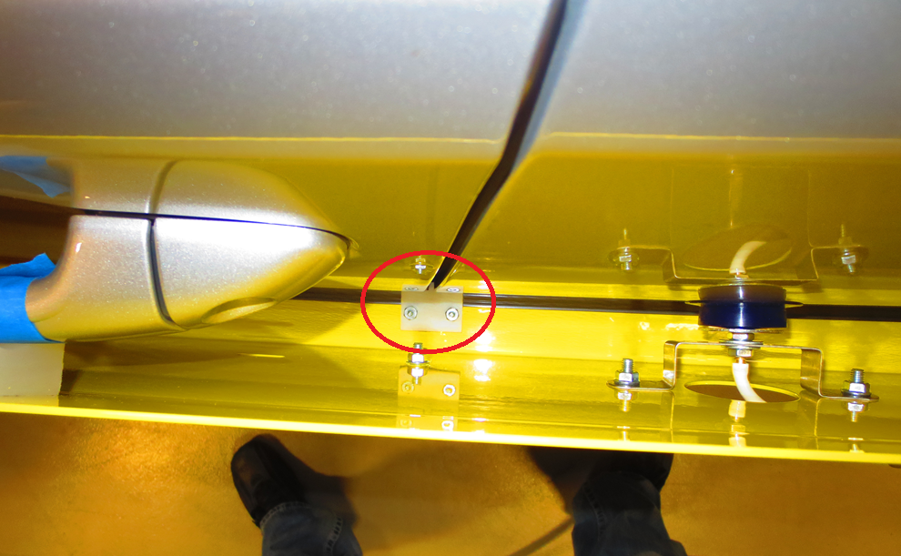
  - Place the center fixture locator into the gap between the front and rear doors. (Fig. 2-3)
Center Fixture Locator
  - Position the placement fixture against the doors so that the fixture molding shelf (bottom of fixture) is contacting the doors.
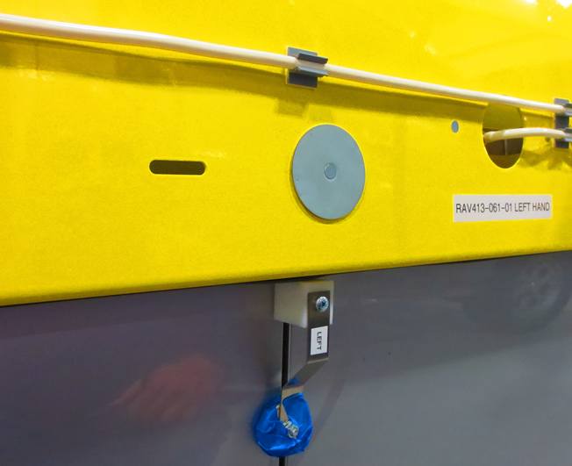
  - Turn on the vacuum actuator to the suction cups and confirm all suction cups are in contact with the doors by gently pushing them against the doors. (Fig. 2-2)
Fig. 2-3
  - Apply masking tape to the gap between the front and rear doors where the magnetic door gage block will contact the vehicle surface. (Fig. 2-4)
Front Door
Fixture Molding Shelf
Masking Tape
  - Insert the corresponding magnetic door gage block into the door gap between the front and rear doors and butted up against the fixture molding shelf. (Fig. 2-4)
Door Gage Block

Fig. 2-4

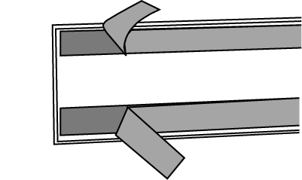
- Body Side Molding Installation.
Fig. 3-1
  - On the inside of each of the four moldings is identified as to their correct position on the vehicle. While carefully holding the molding by its edges, completely remove all tape liners from the acrylic foam tape strips. (Fig. 3-1)
NOTE: Once the liners are removed from the molding, the surface of the foam tape must not be touched!

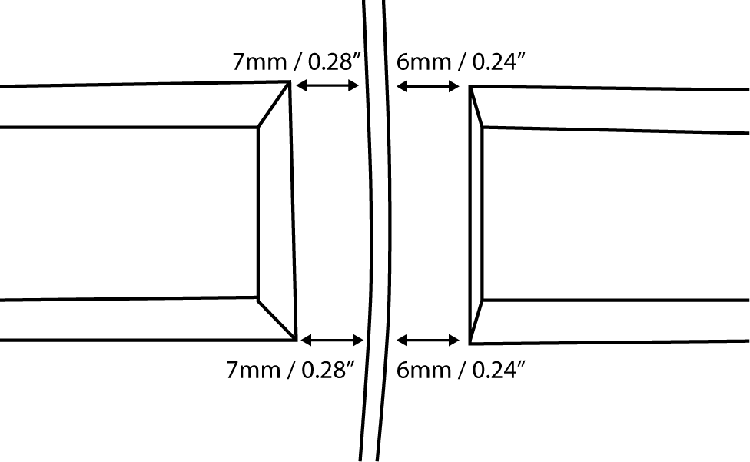
  - Start with the front door using the appropriate front molding (longer molding).
7.8mm -0.0/+1.0mm
7.5mm -0.0/+1.0mm
  - The opening between the doors should look like Fig. 3-2. Tolerance for flushness in the vertical direction of the front and rear molding in relation to each other is 0.0mm +/- 1.0mm. The door gage block will assist in maintaining these tolerances.
7.8mm -0.0/+1.0mm
7.5mm -0.0/+1.0mm
Fig. 3-2
Front Body
Side Molding
Rear Body
Side Molding

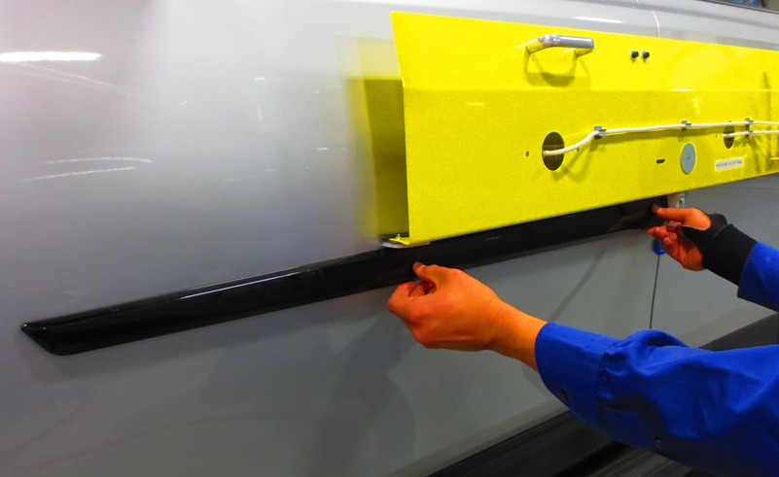
  - Place the front door molding against the fixture molding shelf far enough away from the door sheet metal so the molding does not yet stick to the door (Fig 3-3)
Spacer Block
Door Gage Block
Front Door
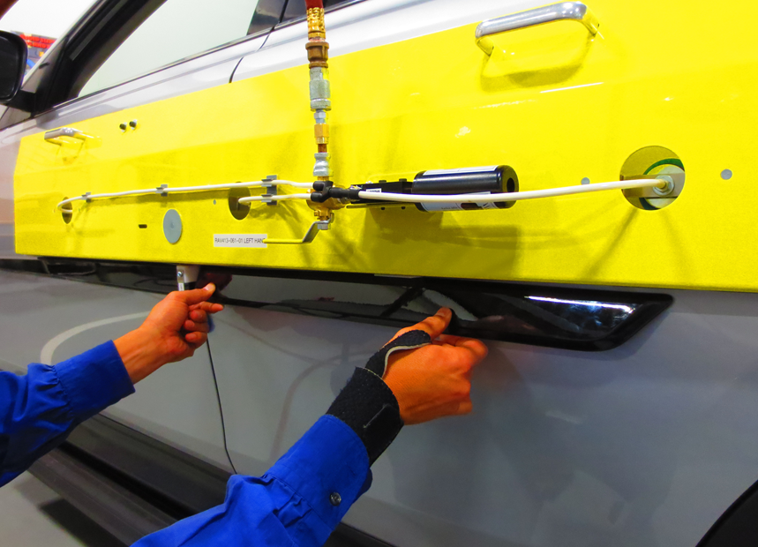
  - Butt the flat end of the molding against the door gage block (Fig. 3-3). As you press it against the door surface work your way to the opposite end keeping it in contact with the fixture molding shelf and in contact with the spacer block.
Fig. 3-3

CAUTION: Do not allow both ends to contact and stick to the door before the center contacts.
Spacer Block
Door Gage Block

  - Repeat for the installation for the rear molding on this same side of the vehicle (Fig. 3-4).
Rear Door
Fig. 3-4

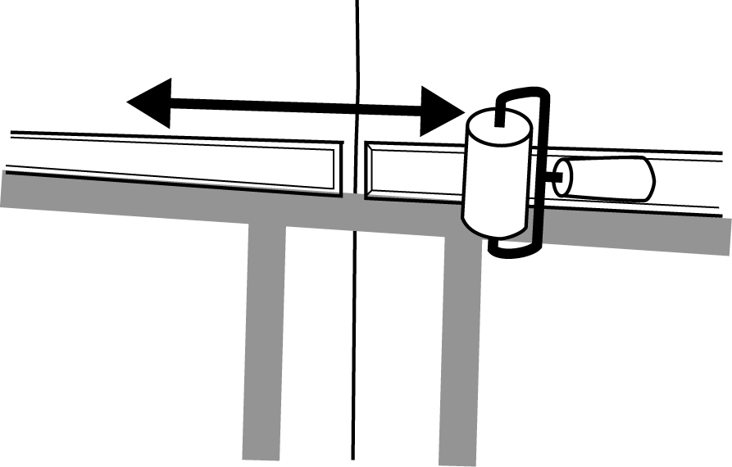
Fig. 3-5
Hand roller
  - Using the hand roller and clean rag, roll around the perimeter of the parts with firm pressure to ensure complete adhesion of the tape to the door surface. Use the rag to protect the sheet metal and the body side molding (Fig. 3-5).
  - Repeat this section for the other side of the vehicle.

Accessory Function Checks
Check visual alignment

Check for proper tape adhesion.

Vehicle Function Checks
None Required

The moldings should be visually straight.

Confirm 100% tape adhesion completely around the part between the Body Side Molding and door sheet metal.

Vehicle Appearance Check
After accessory installation and removal of protective cover(s), perform a visual inspection.

Ensure no damage (including scuffs and scratches) was caused during the installation process.
(For PPO installations, refer to TMS Accessory Quality Shipping Standard.)

